
Adding Blackout Dates in EdisonLearning

- Select the Gear icon located at the top of the page.
- From the Control panel page, click on Institutions on the right-hand side of the page.
- Click on the magnifying glass icon  next to your institution.

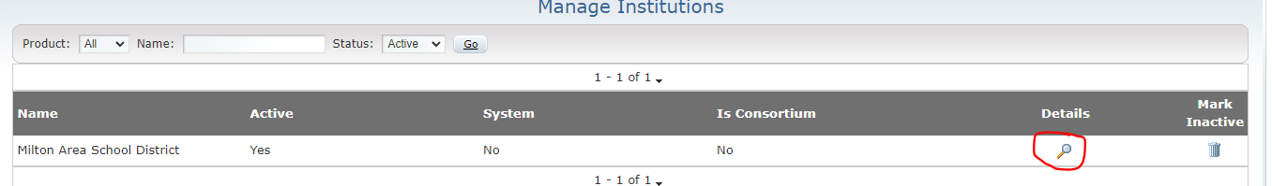

- Under the School Year tab, click on the current school year.

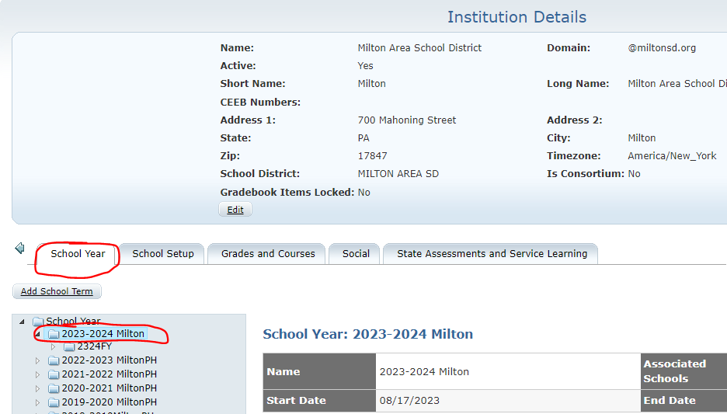

- Scroll down to the calendar and click on the date you wish to add as a blackout date.

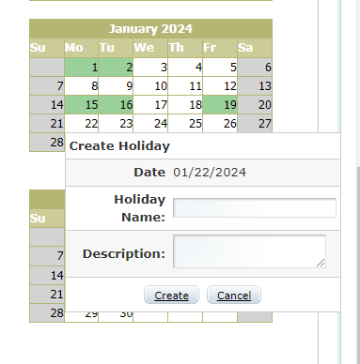

- Select Create, and the date will be added as a blackout day in EdisonLearning.

