**How an Institutional Admin. Can Create a New User**

1. Log into your Genius account.
2. Click on the Affiliations tab.
3. Choose your school affiliation (this should be the only one on the list)
4. Then select “Add Users” on the left hand side.

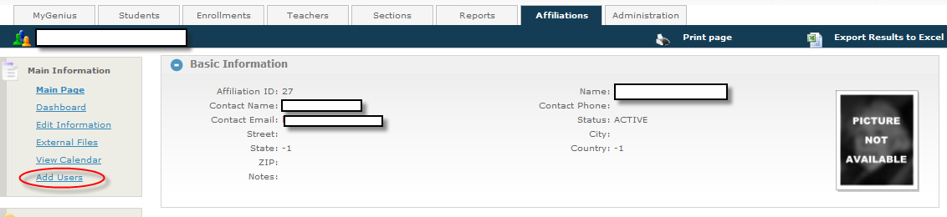

1. This will bring you to the next screen in order for you to add all the user information.

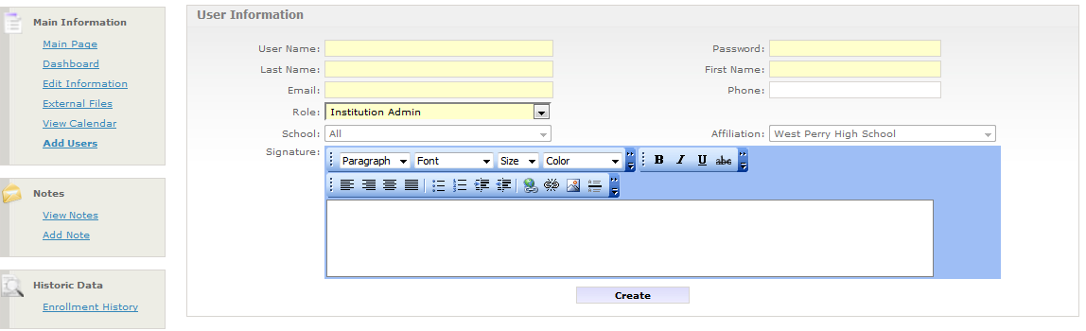

1. Click “create” and the user will now be added.

Updated 2/17/16