How to Make Users Inactive in Accelerate Education

- Choose Users from hamburger menu in top-left:
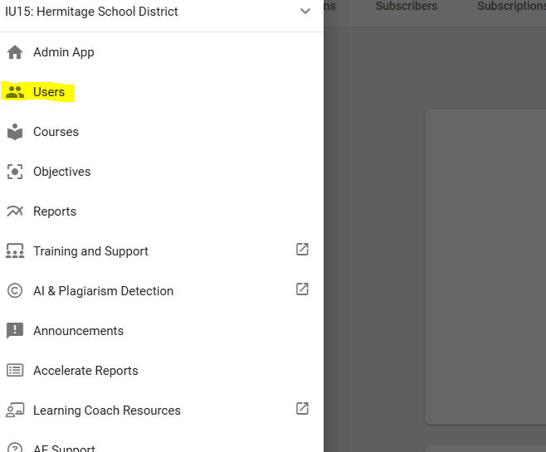

- Click the user ID to open details of user
- Uncheck Active
- Hit Save
