CAOLA for Administrators: The Essentials

Find Your Way Around Genius
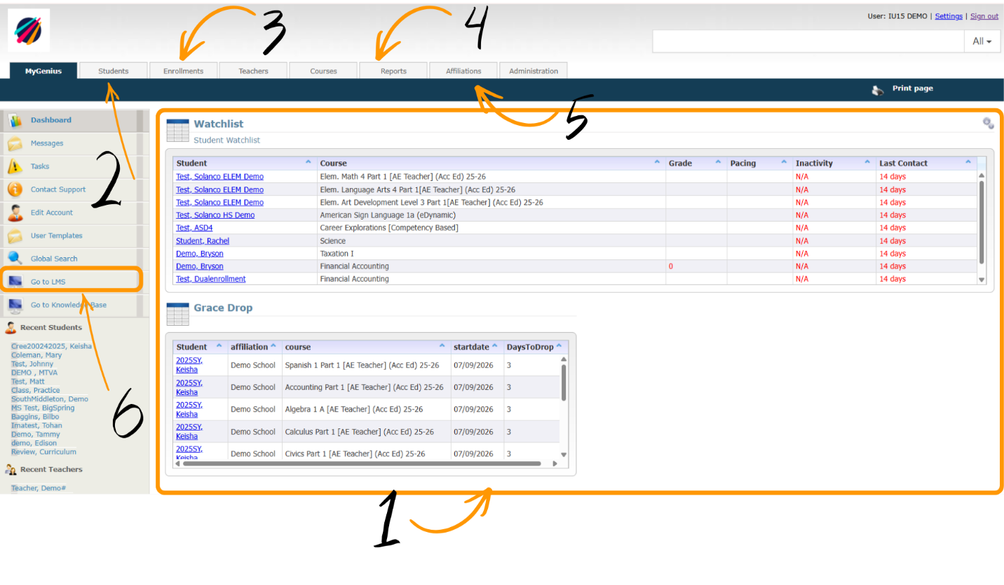
# | Tool | Purpose
1 | Genius Dashboard | Quick snapshot of student status.
2 | Students Tab | Navigate student and enrollment management (student creation, access student profiles, course enrollment).
3 | Enrollments Tab | Auto-email and progress reports.
4 | Reports Tab | Progress monitoring and data reports.
5 | Affiliation Tab | Adjust affiliation settings, bulk close courses.
6 | Go To LMS | Navigate to learning management systems.

Your Administrative Toolkit
Tool | Purpose
Genius SIS | Student information, enrollments, reports, and communication.
LMS (Accelerate, Harris, Lincoln, & eDynamic) | Student coursework and instructional settings.
Knowledge Base | Help articles, tutorials, forms, and procedures.
CAOLA Support/Help Desk | Technical support and tickets.

Your Responsibilities
Note: You may have more or less of these tasks – every program is different!
- Manage student enrollment (creating student profiles, adding courses).
- Monitoring student progress.
- Communicate with staff, students, and families.
- Support local teachers.
- Coordinate with CAOLA staff when needed.

Genius SIS Essentials – Getting Started
- Customize your dashboard.
- Verify affiliation settings, such as passing threshold.
- Bookmark frequently used pages (CAOLA Login, Knowledge Base, Course Catalog).
- Add your school calendar
- Set-up auto-emails
- Create and find staff accounts

Customizing Your Dashboard
- From your dashboard, click the gear icon in the top-right corner.
- Add, remove, or resize reports.
- Click save.

Verify Affiliation Settings
- Select Affiliation tab along top navigation bar.
- Select Affiliation.
- Select Edit Information.
- Confirm settings or adjust.
- Click save.

Add Your School Calendar
- Select the Affiliations tab
- Select your affiliation
- Click “View Calendar” on left-hand side
- Click Add New Event at top-left
Note: You can only add events one day at a time. For example, for Winter Break, you’d need to add the holiday to each date your school is closed.

Set Up Auto-Emails

Part 1: Create the Template
- Open the Administration tab
- Under System Setup, select Templates
- You can view and copy a current template first OR you can draft your own in the next steps
- Click Add Template
- Under Type, Select Auto
- Paste your template or draft your own here
- Save

Part 2: Automate the Email
- Open the Enrollments tab
- Enter your search criteria (this will identify who your email goes to)
- Select Add New Auto Email
- Select your template from the drop-down menu
- Select who you’d like to receive in addition to the student
- Determine the frequency
- Save

Create and Find Staff Accounts
Creating and Finding Users in Genius
There are several types of staff accounts you can create. Each role has different abilities and permission levels.

Managing Individual Students
- Create the student profile/Genius account
- Assign Advisor
- Fill out Special Education Form, if applicable
- Enrolling in courses
- Make course changes, if needed

Creating Student Profile
Student Account Creation - Video
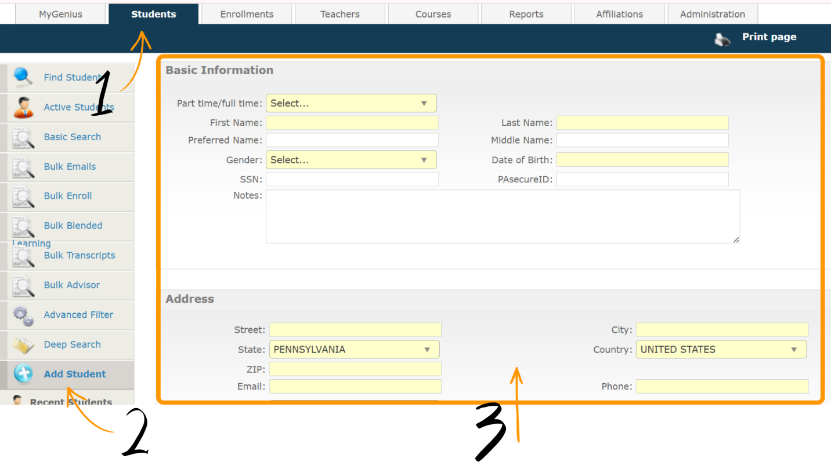
- Click Students Tab
- Select Add Student
- Fill out form, yellow fields are required
- Click save

Assigning Individual Advisors
Before you can enroll in courses, you must assign an advisor. This will be the individual responsible for monitoring this student and their progress.
- Open the student’s tab
- Locate the student profile and open it
- Select Associate to Advisor on the left navigation menu
- Click add new association
- Select the role and user
- Save

Special Education Form
Special Education Form Video
If the student has an IEP, 504, or GIEP, you must complete the Special Education Form to ensure accommodation is applied to their courses.
- Open the student’s tab
- Select the student profile
- Under Actions on the left navigation menu, select Special Education Form
- Complete Form – if you need support completing the form, check the CAOLA Knowledge Base for video tutorial.
- Save
Note: Make sure the supporting document is uploaded in the files section of the form. Uploading external files will not apply the accommodations.

Individual Enrollment
- Open students tab
- Select student profile
- Select Enroll in Section under Actions on the left navigation menu
- Complete form
- Enroll
Note: Make sure you receive a green check mark before exiting – this indicates successful course enrollment.

Individual Course Adjustments
Dropping enrollments should be done if the student is not planning to finish the course and is dropping it from their transcript. Completing a course should be done if a student is taking a grade for the course, even if they did not complete all assignments.
The process for dropping and completing a course is the same, except for the final step.
- Open the student’s tab
- Select the student profile
- Under enrollments on the left side, select Current Enrollments
- Check off the courses you need to make changes to
- Select one of the three options:
  - Drop Selected
  - Complete Selected
  - Change Dates (use this ONLY to change the end date)

Communicating with Individual Students
- Open the Student’s tab
- Select the student
- Click Send Email under their demographic information

End of Term: Individual Transcripts
Once the term is completed, you may want to pull the Genius transcript to assist with grade tracking. The Genius transcript will only display completed CAOLA courses – it will not show dropped or active courses.
- Open the Student’s tab
- Select the student
- Select “View Transcript” under Historic Data on the left-hand side

Bulk Student Management
This section will take you through the steps to complete the student management tasks in the previous section in bulk, except for the Special Education Form.

Bulk Student Upload
Bulk Student Upload Video
Student profiles can be created in Genius in bulk by filling out the bulk student upload CSV. This document must be filled out 100% correctly for the upload to be successful.

Bulk Advisor
- Open the student’s tab
- Select Bulk Advisor on the left navigation menu
- Enter search criteria
- Select students
- Click Assign
- Select the role and user
- Save

Bulk Enrollment
- Open students tab
- Select Bulk Enroll on the left navigation menu
- Enter search criteria
- Select students
- Click Bulk Enroll at bottom of list
- Fill out enrollment information
- Save

Bulk Enrollment Changes
Dropping enrollments should be done if the student is not planning to finish the course and is dropping it from their transcript. Completing a course should be done if a student is taking a grade for the course, even if they did not complete all assignments.

To change dates, drop, or complete courses for multiple students at one time:
- Open the Affiliations tab and select your affiliation
- On left navigation menu, select Current Enrollments
- Select the enrollments
- At bottom of the page, select the change you wish to make
Note: Do this at the end of term to close out completed courses. Some vendors (AE and eDynamic) will close automatically once grades are submitted.

Bulk Student Communication
- Open the Student’s tab
- Select Bulk Email
- Enter your search criteria
- Select the students who should receive the email
- Select Bulk Email at the bottom of the page

End of Term: Bulk Transcripts
Transcripts, Advanced Grade Level, Bulk Alumni, Bulk Withdraw
Once the term is completed, you may want to pull the Genius transcript to assist with grade tracking. The Genius transcript will only display completed CAOLA courses – it will not show dropped or active courses.
- Open the Student’s tab
- Select Bulk Transcripts
- Enter search criteria
- Select students
- Select an option at the end of the page
Note: This is also where you can advance students to the next grade level, mark graduated seniors as alumni, or bulk withdraw students from the program.

Progress Monitoring
Stay in the Know: A Guide to Genius Reports
To monitor student progress or track attendance/logins, utilize the many reports available in Genius. If you need a custom report, please reach out to your CAOLA Account Manager.

Go to LMS
To navigate to any of our vendor’s Learning Management Systems (LMS), start on the MyGenius page or the main screen when you first login.
- Click Go to LMS on the left-hand side
- Click the computer icon beside the LMS you want to access

Adding Blackout Dates
Accelerate Education Blackout Dates
Harris Digital Learning Blackout Dates

Applying Domain Settings (Accelerate Education)
Global Assessment Modification Form

