The CAOLA team has partnered with other intermediate units and online programs throughout Pennsylvania to collaborate on the PIMS reporting feature in GeniusSIS. Schools are able to pull local and vendor teacher PIMS information directly from Genius; only teachers assigned to students at a specifc school will be included on the pulled report, eliminating confusion and extraneous information. Both PIMS reports cover the most current required information from the PA Dept. of Education. Vendor teacher information will be uploaded by the CAOLA team while schools will be responsible for updating their local teacher accounts. Please review the following information to learn how to access the reports and edit teacher information.

PIMS Reports
- Login to GeniusSIS and select the ‘Reports’ tab.
- On the left side of the screen under ‘Activity’ will be the two reports. Both ‘All Teachers with Enroll’ and ‘All Teachers with Certification’ will pull the PIMS information, select the report you would like to open.
  - Important note: the ‘All Teachers with Certification’ will only pull teachers who have their certifications (specifically PA-certified) loaded into Genius and is associated with a specific school. ‘All Teachers with Enroll’ will show you all teachers associated with a school, even those without PA certifications.
- When you select the report, you will filter the Search Criteria (start date, end date, and affiliation) for your school district’s information. Select ‘Get Data’.
- Once the report open, you will be able to download the report into Excel for a better view.
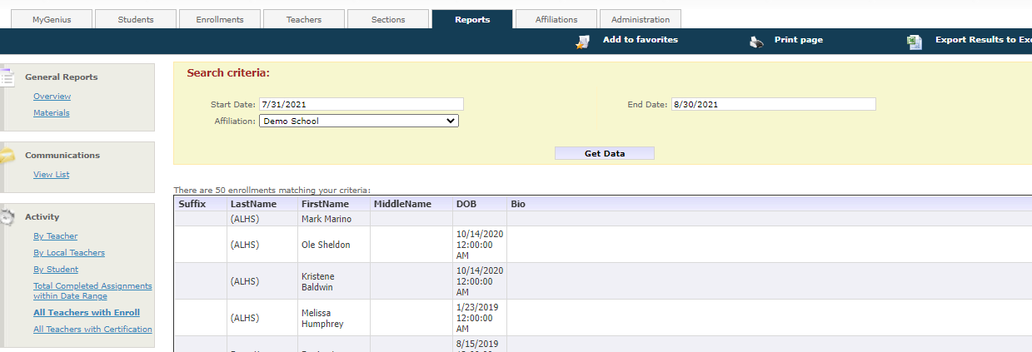

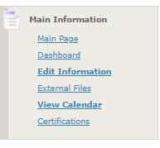
Editing Teacher Information
- Login to Genius and select the ‘Teachers’ tab.
- Search for the teacher’s name in the search box.
- Once the teacher’s information loads, select
‘Edit Information’.
- On this screen you will update the information
about the local teacher like location code,
years experience, job class, qualifications, and more.
- Review and edit local teacher information frequently
to ensure accurate records.

Updating Teacher Certifications
- Login to Genius and select the ‘Teachers’ tab.
- Search for the teacher’s name in the search box.
- Once the information loads, select ‘Certifications’.
- Select ‘Add new Certification’
- A new screen will pop up and prompt you to enter information off of the teacher’s Professional Certificate.
  - Important note: ‘State Specific Certificate ID’ references the teacher’s PPID number.
- Once information has been updated, select ‘Save’.
- If you need to edit the certificate or archive the certificate, select the pencil/paper icon to the left of the certificate for the edit screen to pop up.

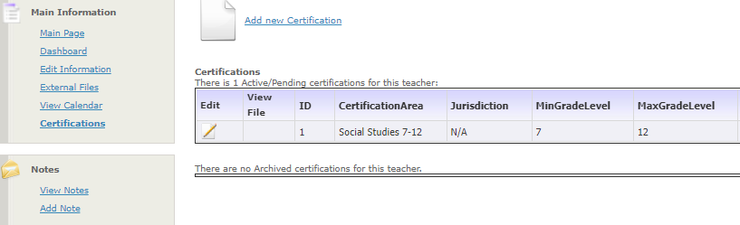

For additional questions regarding PIMS and the information within the reports, please contact the CAOLA team.

